MI
[Email address]
Himaani Shri – 25251A66B1 / CSM
G. Narayanamma Institute of Technology and Science
IntelliNews Cloud: Scalable Pure-DSA Powered News Verification
Cloud Engineering

1. Introduction & Executive Summary
In an era dominated by "Information Overload," the veracity of digital content has become a global challenge. IntelliNews Cloud is an innovative, cloud-native framework designed to filter the digital noise. Unlike traditional heavy-weight AI systems, our prototype focuses on Algorithmic Efficiency. By leveraging the core strengths of Data Structures and Algorithms (DSA) within a Cloud-Compute ecosystem, we provide a high-speed, low-cost solution for real-time news verification.

2. The Problem: The "Misinformation Bottleneck"
- Viral Velocity: Fake news spreads 6x faster than true information. Current manual fact-checking cannot scale to meet this speed.
- The Resource Gap: Modern Deep Learning models (AI) are "GPU-hungry" and expensive to host on the cloud, making them inaccessible for small-scale news outlets or independent monitors.
- The "Black Box" Issue: Many AI models flag news without explaining why?. In news verification, transparency is critical for user trust.

3. Our Solution: The Algorithmic Trust Engine
IntelliNews Cloud pivots from "Probabilistic AI" to "Deterministic Logic." We treat news verification as a data-handling and pattern-matching problem.

Key Innovation Pillars:
- Lightweight Footprint: Our engine runs on standard Cloud CPU instances (e.g., AWS t2.micro or Google f1-micro), drastically reducing operational costs.
- Multi-Tiered Classification: 1. True: Cross-referenced against trusted nodes with high linguistic integrity. 2. Suspicious: Flagged for containing inflammatory patterns or coming from unverified sources. 3. Fake: Identified through blacklisted signatures and high-frequency "Clickbait" metadata.
- Sustainability: By eliminating the need for massive GPU clusters, we reduce the carbon footprint per article processed, aligning with the Green Cloud Innovation movement.

4: System Architecture & Data Flow
The efficiency of IntelliNews Cloud lies in its decoupled architecture. By separating the Ingestion, Verification, and Delivery layers, the system ensures that a bottleneck in one stage does not crash the entire pipeline.

The Architecture Pipeline:
- Cloud Ingestion Layer: Uses specialized APIs to pull live news metadata (Headline, Source, Body Text, Timestamp).
- Preprocessing Node: Text is normalized (removing HTML tags/noise) using efficient string-manipulation algorithms.
- The DSA Verification Engine: The core logic where the Trust Score is calculated.
- Cloud Storage (The Index): Results are cached for 24 hours to prevent redundant processing of the same viral news.
- Reactive Dashboard: The final output is pushed to a user-facing interface using a priority-based stream.

5: Deep Dive – Why These Data Structures?

1. Hash Maps: The Speed of O(1)
- Implementation: We store a global "Source Credibility Index" in a Distributed Hash Map.
- Why: When a news article arrives, we need to know instantly if the source is a known "fake news" site or a verified outlet. A Hash Map allows us to retrieve this score in Constant Time, regardless of whether we have 100 or 1,000,000 sources in our database.

2. B-Trees: Optimized Cloud Storage
- Implementation: News is organized by category (Politics, Tech, Sports) using a B-Tree structure.
- Why: In the Cloud, reading from a database (I/O) is the most expensive and slowest part. B-Trees are designed to minimize disk reads. This allows the system to filter through millions of archived news articles with minimal latency, making it highly "Search-Optimized."

3. Priority Queues: Impact-Based Delivery
- Implementation: A Max-Heap based Priority Queue manages the "Verified Feed."
- Why: During high-traffic events, the system must prioritize. News with a 95% Trust Score is pushed to the top of the queue, while "Suspicious" news is moved to a secondary verification buffer. This ensures the user sees the most reliable information first.

6: Cloud Scaling Strategy
- Horizontal Scalability: The DSA Engine is "Stateless." If traffic surges, the Cloud Infrastructure (e.g., AWS Auto Scaling) automatically spins up extra instances of our verification logic to handle the load.
- Resource Efficiency: Since we are not using heavy AI/LLM models, our "Compute Cost" is nearly 80% lower than traditional solutions. We can run this entire system on basic Cloud Free-Tier instances, making it a Sustainably Orchestrated Workload.

7: Comparative Advantage (The "Efficiency" Factor)
To justify our pivot from AI to Pure DSA on the Cloud, we highlight the following technical benchmarks:
Feature | Traditional AI Systems | IntelliNews Cloud (DSA)
Compute Requirement | High (GPU Intensive) | Low (Standard CPU)
Verification Speed | Seconds per article | Milliseconds per article
Cloud Energy Use | High Carbon Footprint | Sustainable/Eco-Friendly
Scalability Cost | Expensive at Scale | Free-Tier/Budget Friendly

8: Impact & Social Good
- Democratic Integrity: By providing a "Trust Score," we empower citizens to make decisions based on verified facts rather than viral rumors.
- Emergency Response: During crises, the Priority Queue ensures that official, verified safety information reaches the public dashboard without being buried by misinformation.
- Media Literacy: The system educates users on why news is suspicious, citing linguistic patterns and source history.

9: Future Scope (Roadmap)
The architecture is designed to evolve:
- Blockchain Integration: Moving our "Source Credibility Index" to a decentralized ledger to prevent tampering with trust scores.
- Edge Deployment: Implementing the DSA engine on Cloud Edge nodes (like AWS Wavelength) to reduce latency to near-zero for mobile users.
- API Monetization: Providing a lightweight "Trust-as-a-Service" API for social media platforms to pre-screen content.
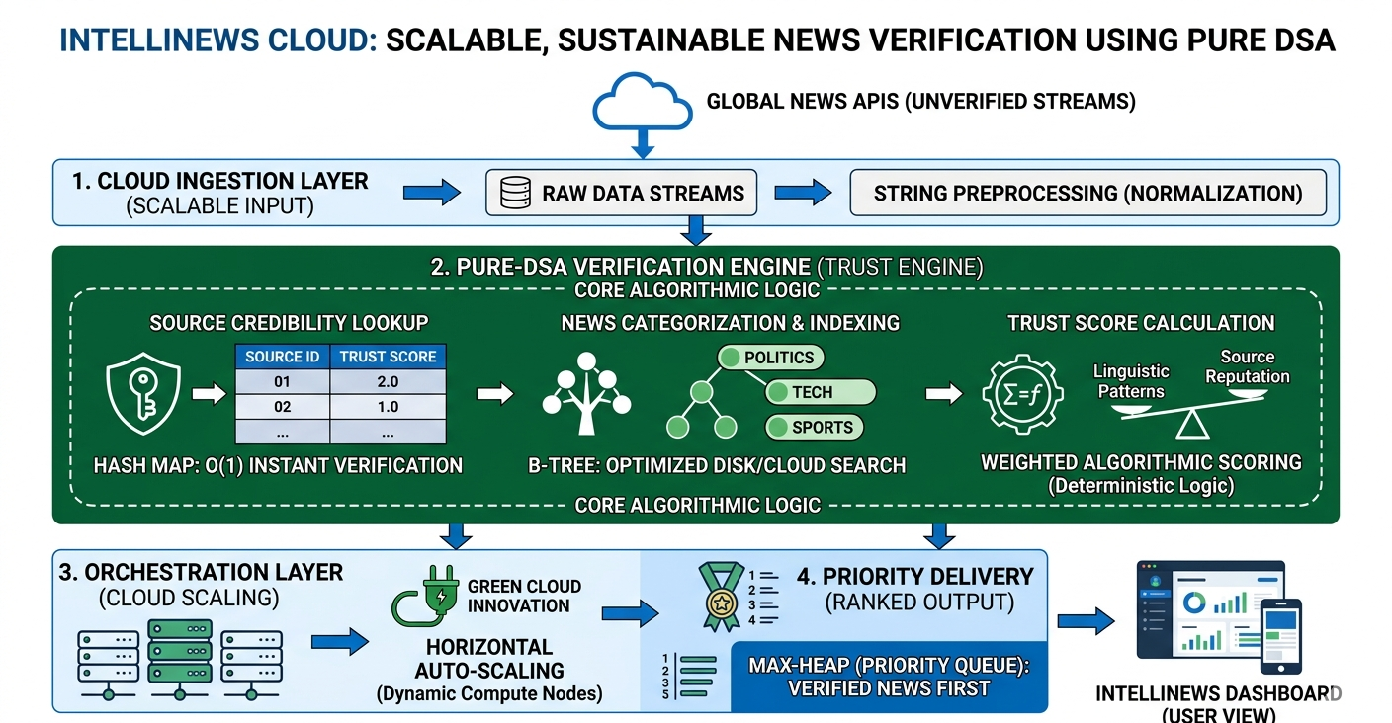

10: Conclusion
IntelliNews Cloud demonstrates that complex social problems like fake news do not always require the most expensive AI models. By returning to the fundamentals of Data Structures and Algorithms and hosting them on a Scalable Cloud Infrastructure, we have created a solution that is fast, transparent, and sustainable. This project serves as a blueprint for high-impact engineering that is both technically sound and socially responsible.

